Free writing

Title: Line Follower Robot
The role of engineers is not only to solve existing problems but also to envision a better future. The aim of this activity is to allow the students to share their ideas that they think will shape the future. These ideas may stem from technological advancements, the role of technology in future, and the needs of society in future and so on. These activities are conducted in class as well as the week end home assignment activities.
Poster presentation: Line follower robot

Introduction:
The Line Follower Robot is an autonomous mobile machine that follows a predetermined path, usually represented by a black line on a white surface. It uses infrared sensors to detect the path and a microcontroller to make movement decisions. This project demonstrates basic principles of automation, robotics, and control systems.

Objective:
To design and develop a simple and cost-effective robot that can automatically detect and follow a line using sensor feedback and control logic

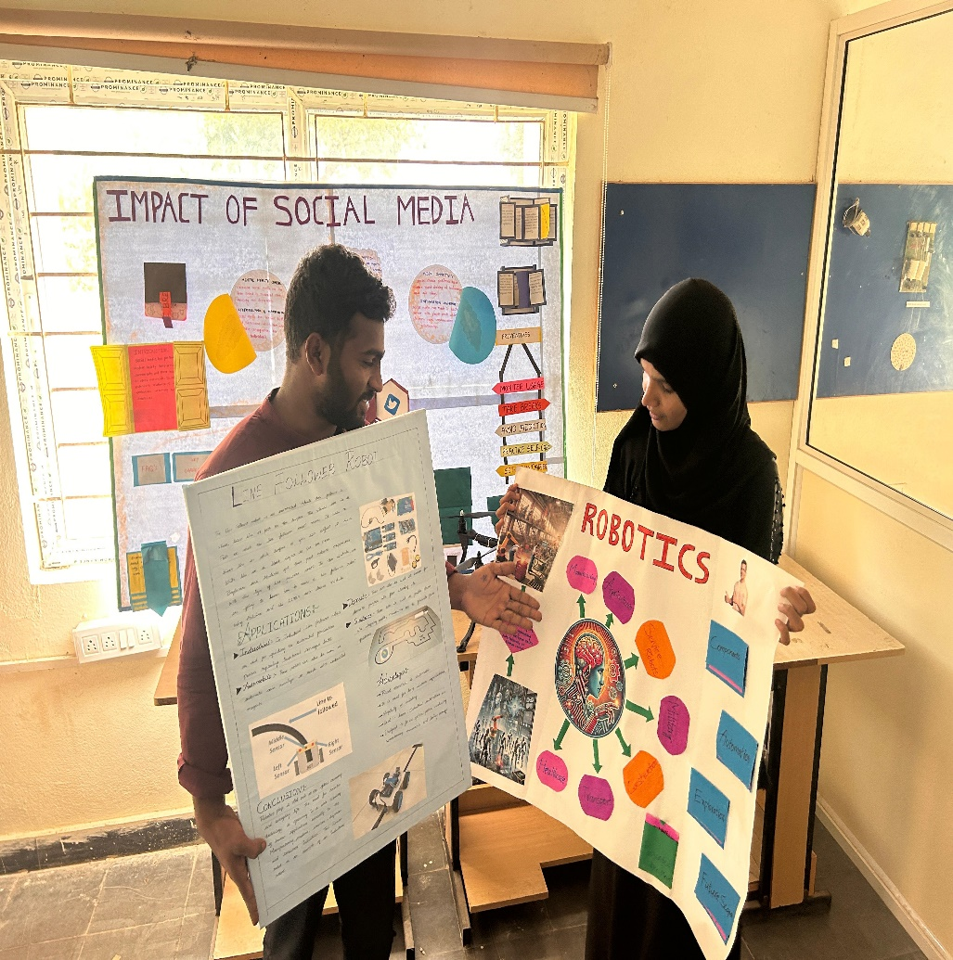

Problem Statement:
In many industrial and domestic applications, repetitive tasks such as material transport or delivery require automation. Manual operation can be time-consuming and inefficient. Hence, a line-following robot can be used to automate these processes efficiently.

Innovation Concept:
This project introduces a low-cost autonomous robot using IR sensors, a microcontroller, and DC motors. The robot detects and follows the line without human intervention. The design is modular and can be upgraded for industrial use or extended to smart automation systems.

Working Principle:
- The IR sensors detect the black line by sensing light reflection.
- The microcontroller (Arduino) receives sensor input and processes it.
- Based on sensor feedback, the motor driver controls the movement of the DC motors.
- The robot continuously adjusts its path to stay on the line.

Components Used:
- Arduino Uno (Microcontroller)
- IR Sensors (3 units)
- L293D Motor Driver IC
- DC Motors (2 units)
- Robot Chassis and Wheels
- Power Supply (12V Battery)
- Connecting Wires

Applications:
- Industrial material handling systems
- Warehouse automation
- Educational and research robotics
- Automated guided vehicles (AGVs)

Advantages:
- Low-cost and easy to build
- Simple design and programming
- Reliable and efficient for small-scale automation
- Expandable for advanced robotics applications

Expected Outcome:
The robot successfully follows a line path automatically using sensor feedback. It demonstrates how microcontrollers and sensors can be integrated to achieve intelligent motion control.

Conclusion:
The Line Follower Robot project demonstrates a basic yet powerful concept in robotics and automation. It serves as a stepping stone toward the development of autonomous vehicles and smart industrial systems.

Title: ROBOTICS INNOVATION REPORT

1. Introduction
Robotics is an interdisciplinary branch of engineering and science that deals with the design, construction, operation, and application of robots. Robots are automated machines that can perform tasks with precision, efficiency, and in some cases, autonomously. Robotics combines mechanical, electrical, and computer engineering principles to create machines that assist humans in industrial, medical, domestic, and research applications.

2. Objective
- To study and develop intelligent machines capable of performing tasks autonomously or semi-autonomously.
- To integrate sensors, actuators, and control systems for real-time decision-making.
- To innovate solutions for industrial automation, healthcare, and service robotics.

3. Problem Statement
Many tasks in industries, medicine, and daily life are repetitive, dangerous, or require high precision. Manual execution can be inefficient, unsafe, or error-prone. Robotics provides innovative solutions by automating these tasks, improving safety, efficiency, and accuracy.

4. Innovation Concept
The project focuses on creating robotic systems that:
- Can sense and respond to the environment using sensors.
- Execute tasks autonomously using programmed logic.
- Can be applied in manufacturing, healthcare, logistics, and research.
- Enable human-robot collaboration for enhanced productivity.

5. Working Principle
- Sensing: Sensors detect environmental data (e.g., distance, temperature, pressure).
- Processing: Microcontrollers or computers process sensor data and decide the robot’s actions.
- Actuation: Motors, servos, or other actuators perform physical actions.
- Feedback: Continuous monitoring allows the robot to adjust its behavior in real time

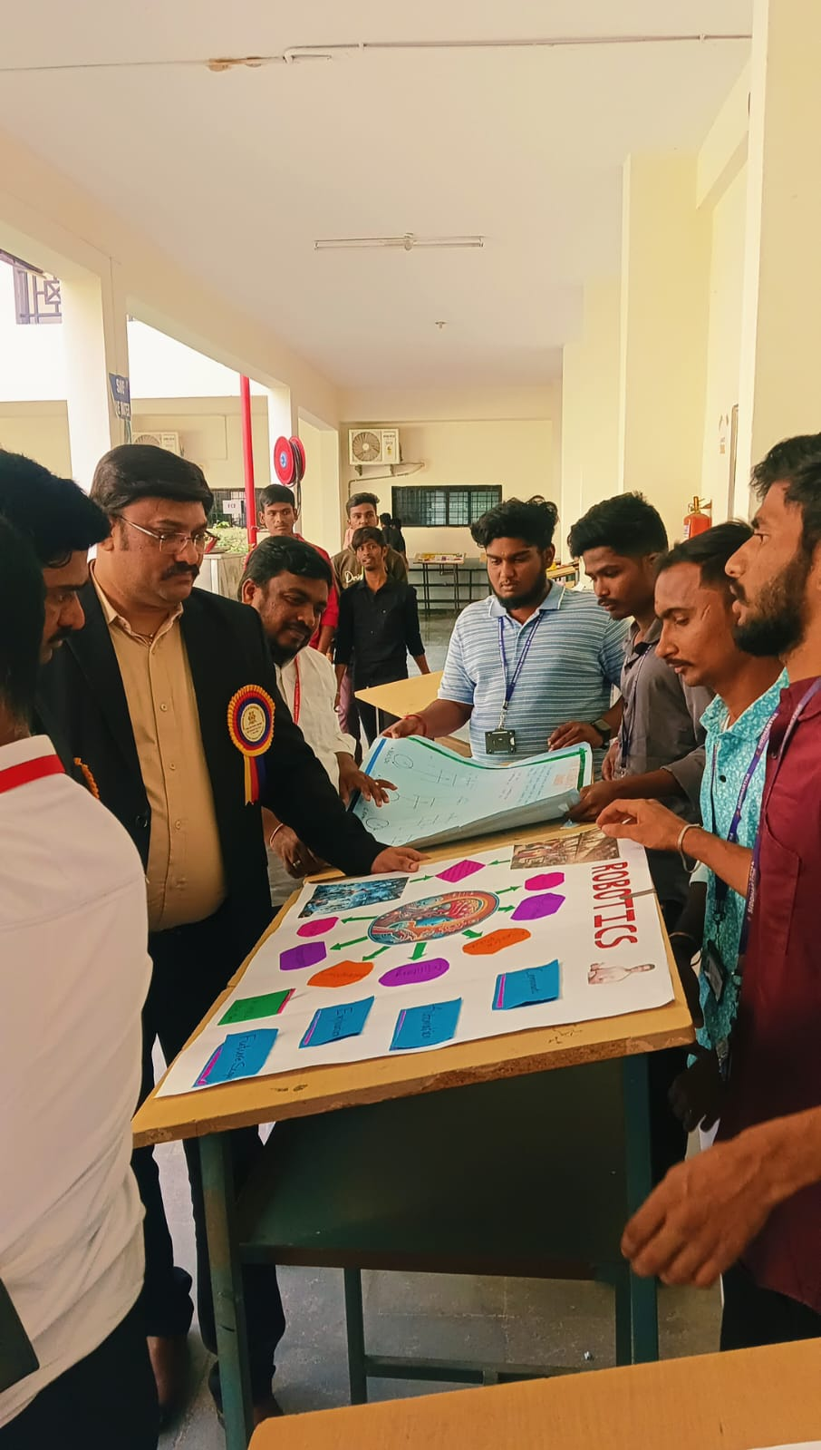

7. Applications
- Industrial automation (assembly lines, material handling)
- Healthcare and medical robotics (surgery, rehabilitation)
- Military and defense robots
- Space exploration robots
- Service robots for domestic and commercial purposes
- Research and education in STEM fields

8. Advantages
- Enhances precision and productivity
- Reduces human labor in dangerous or repetitive tasks
- Operates in hazardous environments
- Can work continuously without fatigue
- Provides innovative solutions for multiple sectors

9. Expected Outcome
- Development of a functional robotic prototype or system.
- Demonstration of autonomous or semi-autonomous task execution.
- Practical application in industrial, educational, or service domains.10. Conclusion
Robotics is a transformative technology that bridges mechanical, electrical, and computational systems. Innovations in robotics enable humans to perform complex tasks efficiently, safely, and accurately. Continued research and development in robotics have the potential to revolutionize industries, healthcare, and everyday life.
For more details, visit: https://www.siddhartha.ac.in/mech.php

